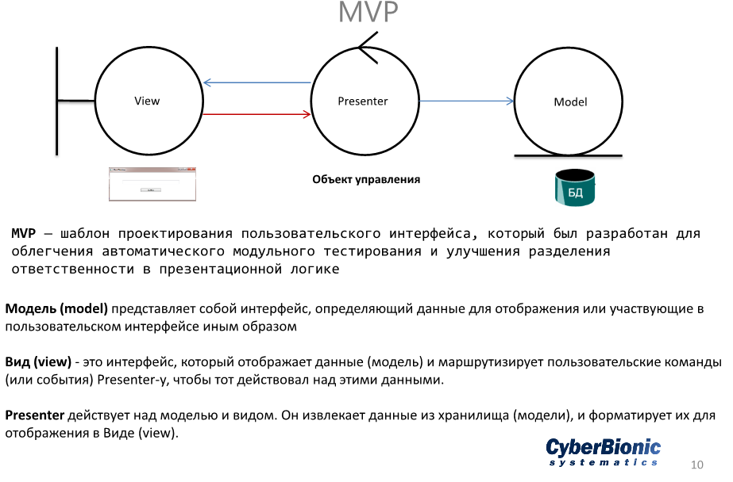

Class Model

using System;

// Model

namespace MVP

{

class Model

{

public string Logic(string s)

{

return string.Format("Работа: Model.Logic({0})", s);

}

}

}

Class Presenter

using System;

// Presenter

namespace MVP

{

class Presenter

{

Model model = null;

MainWindow mainWindow = null;

public Presenter(MainWindow mainWindow)

{

this.model = new Model();

this.mainWindow = mainWindow;

this.mainWindow.myEvent += new EventHandler(mainWindow_myEvent);

}

void mainWindow_myEvent(object sender, System.EventArgs e)

{

string variable = model.Logic(this.mainWindow.textBox1.Text);

this.mainWindow.textBox1.Text = variable;

}

}

}

Class View (MainWindow)

using System;

using System.Windows;

// View

namespace MVP

{

public partial class MainWindow : Window

{

public MainWindow()

{

InitializeComponent();

new Presenter(this); Связь с классом Presenter

}

public event EventHandler myEvent = null;

private void button1_Click(object sender, RoutedEventArgs e)

{

myEvent.Invoke(sender, e);

}

}

}